[Medal Discovery - By Dan Joe O Keeffe Cultural & Language Officer , Dromtarriffe GAA]

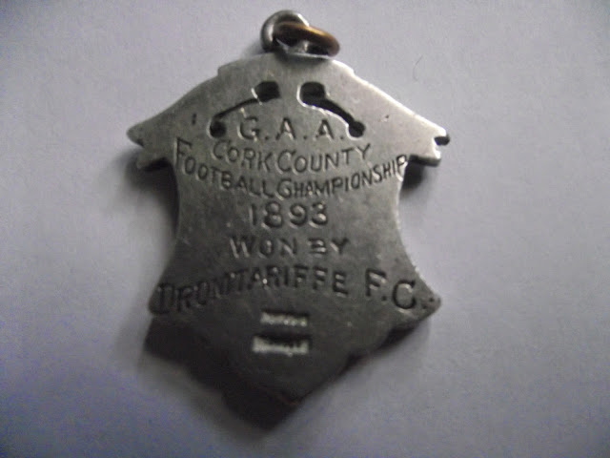

The recent discovery of a 1893 Dromtarriffe County Championship Football medal , recalled what was generally agreed as the Clubs first " Golden Era". Having won the 1893 County championship , Dromtarriffe went on to contest the All Ireland final in the Pheonix Park ( Dublin) against a Wexford Town side " Young Irelanders " . The game failed to finish with the championship awarded to the Wexford side .
In 1962 , a young man , John Travers, who was a playing member of Nemo Rangers Club in Cork , picked up on Patricks Street , near Mangans Clock, the Dromtarriffe medal appeared to have slipped from a chain , perhaps that of a pocket watch. While recently going through medals won during his playing days with Nemo Rangers , John came accross this long lost medal. Feeling that it should return to the club of its origin , John through the "Dromtarriffe GAA Website" contacted the Club secretary Noel O Sullivan . On a recent visit to his native city John presented the medal in pristine condition to members of the club. The reappearance of this medal beggers the question of whom of the victorious team was the proud recipient from a chapter of Dromtarriffes Glorious past.
For the record - Dromtarriffe easily saw off all competition to win the North Cork Championship of 1893. Having received a walkover from Clondrohid in the semi final they faced Castlematryr in the County final and after extra time Dromtarriffe won on a score line of 2-4 to 2-2. This match was played in Fermoy. Kerry failed to field a team and Dromtarriffes Cork selection went straight to the All Ireland final.
The Dromtarriffe team was : John O Keeffe , Capt, Pat Forde, Tim Burton, Paddy Quinlan, Danny Daly, John Forrest, Den Murphy, Con Murphy, Mick Murphy, Timmy Daly, Jerry Kenneally, Jim Murphy, Pat ( Gardiner) O Sullivan , Mick Buckley, Danny O Hanlon , Tom Donegan.
Uploaded by Sharon O Keeffe Club PRO.

Footnote- For further information on this Golden era of Dromtarriffe GAA - check out the link entitled Leaving Cett History project by Daniel O Keeffe who researched this for the 2013 Leaving Cert.

