2018, a Pros dream season,will live in the memories of all Dromtarriffe supporters for many years as one where our players exceeded our expectations in both hurling and football bringing home their first Duhallow JAHC title which was followed by the County JAFC and narrowly losing out on the ultimate Munster honours after extra time.
In my role as club PRO, I got to enjoy sharing these achievements with club supporters both within the parish and beyond – even though sometimes live tweeting from the matches ( final results) was a bit late when caught up in the celebrations! The following is my report on the 2018 season......
Our first club event of 2018 was to celebrate the County winning achievements of our U21 footballers in our Annual Social in the Killarney Heights on January 13th – despite the tidy crowd a great night was enjoyed with Michael O Connell as always a wonderful MC.
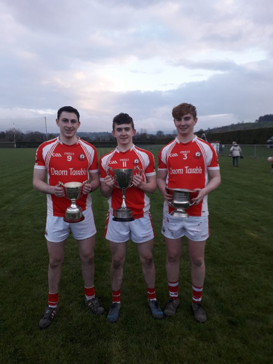
A few week later the U21 Hurlers were back in action to complte the 2017 Duhallow Hurling Championship which they did in style claiming the outright honours for the second year after defeating Kanturk in Rathcoole
Jack Murphy accepted the cup.
It was a great achievement for our U21s to win both Duhallow titles. Pictured here are the 2017 hurling & football captains & vice-captain.

Soon after started the U21AFC and Dromtarriffe continued with their winning ways defeating Kanturk in Rathcoole 3-11 to 1-4 . They then met Duarigle Gaels in the quarter final again in Rathcoole . In an end to end match Duarigle Gaels finished the late point winners and went onto contest the County final in this grade. Thanks to all involved with our U21 footballers – the foundation grade for our Junior teams.
A busy Duhallow league campaign next for our Junior Hurlers and footballers with many games played every 3rd day it put players under pressure to recover and made training difficult for managements . Credit here to both managements and to the Boherbue players as both sides qualified for their respective semi finals – Our hurlers met Banteer in Kanturk – It was a brilliant game of hurling that went to extra time and maybe but due to the volume of games already we may have come out on the right side but still our hurlers gave their all losing out 4-16 to 1-24. Our footballers defeated Knocknagree in the semi final to set up a final meeting with Boherbue in Millstreet. Boherbue ran out the league victors 2-14 to 1-10.
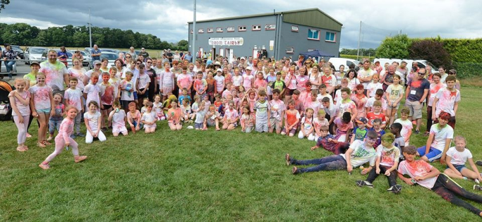
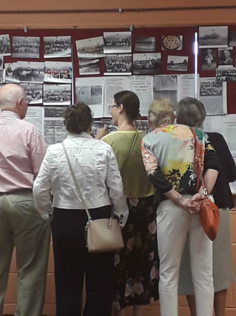
Off the field of play the club was very busy with the launch of our 5 year club development plan on May 24th . Our Major thanks to Jason Murphy for his extensive work in drawing up the plans that were approved at club meetings and displayed throughout the year in the club rooms. Also in July (9Th) we had the first Family Club & history day. Despite the draw of Kerry v Galway ( which we streamed live on the day) and the World Cup Soccer final a large crowd was in attendance at our first Colour Fun Run and the photos taken by Noreen McSweeney and John Tarrant captured some of the days highlights – these were posted on our club facebook page. One of the highlights of the day was the club history day – Noreen McSweeney did an absolutely huge amount of work for this – thanks to her and all our contributors – for anyone who saw the display I am sure you will have enjoyed this reflection of our club. Thanks to everyone who helped in any way with our Family Day – I hope this family day will be held again as it’s not always about making money but giving something to our community, involving everyone.
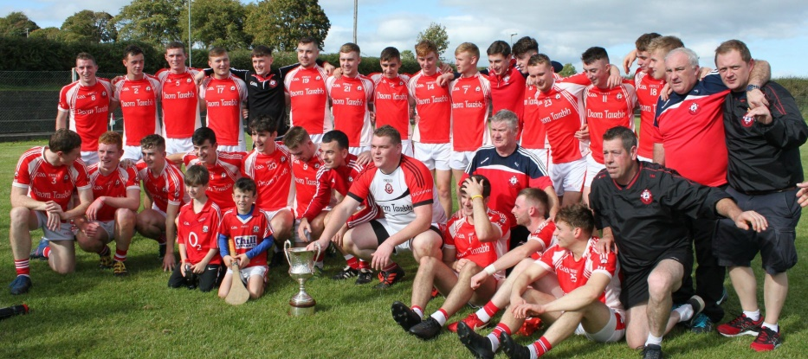
Our Junior hurlers defeated Castlemagner aet, Freemount and the faced Banteer in Kilbrin, heading out of the championship they needed inspiration and a Jack Murphy flick into the net saw them reach the 2018 Duhallow Final. Newmarket ( the league champions) went in hot favourites, but Dromtarriffe had other ideas. On a beautiful September day in Freemount a quick precise brand of hurling stunned our opponents as a complete team performance saw them capture their first Duhallow title – creating a piece of club history.. Many Congrats to everyone involved. The county championship campaign commenced against Ballinascarthy but with our players were over played and hadn’t the same collective energy to get over the line on this occasion.
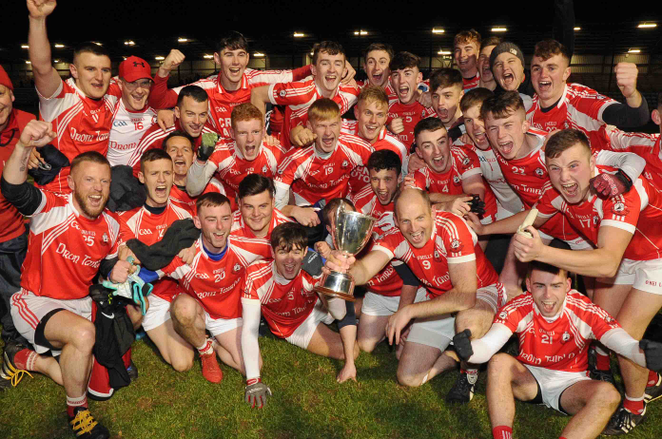
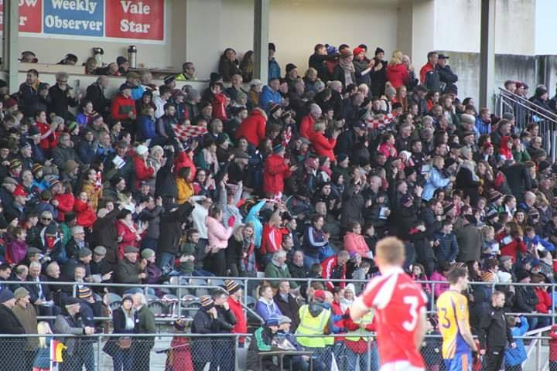
Our Junior Football Championship campaign was boosted by the success of reaching the league final and as a result Dromtarriffe were fancied to make the finals, the semi final v Cullen in Boherbue didn’t pose too much of a problem and so the league finalists also contended the Championship final. Cullen was the venue on September 1- what a game – what an exhibition of football – and maybe with a little bit of luck … however we drew 2-14 a piece and so to a replay. Ballydesmond was the venue and a dogged defensive match was played out – with a conflicting umpires decision proving the winning score for Boherbue . Still the county championship would provide some new opportunities. First up was Charleville in Mallow – No worries for Dromtarriffe, St Michaels again in Mallow, and another fairly straight forward challenge and we easily qualified for the county semi final. Uibh Loaire was going to be a huge challenge – another beautiful day welcomed us in Macroom. A fantasic game of football was played – with some individual outstanding displays keeping the target men of Uibh Laoire from dominating… and yes a qualification for the 2018 County Final. Kilmacabae were the opponents in Pairc Ui Rinn…Our boys were ready….The West Cork Boys started well – and may have extended their lead just before the half time whistle only for a great save from Dan Mann… the second half commenced , Dromtarriffe were down so a few changes were made including bringing on Darren O Connor, who then finished home a brace to the net . Entering the closing minutes level , Jack Murphy tapped over the County championship winner to huge scenes of jubilation amongst the large Dromtarriffe support. Seamus O Sullivan was on hand to collect the county trophy and a weekend of celebrations unfolded. So to the Munster Campaign – an unexpected challenge Kildimo – Pallaskenry from Limerick were our first Munster opponents – Mallow GAA was becoming like a home venue and the support from Dromtarriffe was great to see, a tough challenge but no real worries for our Footballers. Mount Sion Waterford provided the semi final opposition. Daniel O Keeffe stood up on the day scoring 2-9 and so we qualified for the Munster final against Beaufort from Kerry. December 2nd and Mallow the venue – the preview was this was Beaufort with ease – however Dromtarriffe were not there to make up the numbers and in fact at half time thanks to two Seamus O Sullivan goals held a 6 point lead – but Beaufort possessing make players with inter county experience fought back to bring it level at 2-11 a piece on the full time whistle. The extra time was a battle of the defenses – our defense was outstanding so much so that we limited the Kerry side to 2 points over 20 minutes, however tired legs failed to find that elusive levelling point and so we ended our historical football campaign by a 1 point extra time defeat. Massive congrats to everyone who was involved with our Junior Footballers for giving some many memories and a brand of attractive football which highlighted our talented players throughout the team and subs who also contributed many with very important plays. We look forward to the exciting challenges of 2019 in the County Intermediate ranks.
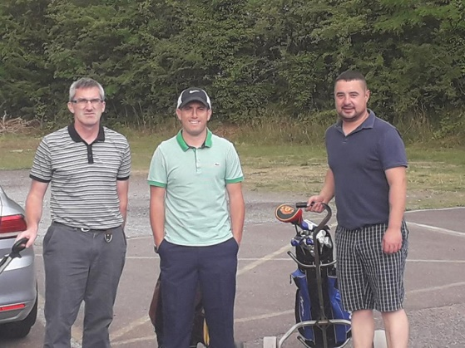
Back to off the field and in August we had our Golf Classic – Denis Murphy and his committee organized this successful event held in Kanturk Golf Course- thanks to all who played or supported the event by purchasing tee boxes.

Our Major fundraising event of the year too place in the Charleville Park Hotel on November 10th – The credit to the event goes in particular to 2 very hard working women Mary Collins & Catherine Ferns – and also to Noreen McSweeney for her promotion before and during the event. With the assistance of our 15 couples from the parish are surrounding area a great night was promised and it did deliver. On the night Michael O Connell and Jackie Feely did a fantastic job co hosting our volunteers took care of the doors, seating and back stage duties and over 800 people enjoyed a wonderful night.
Final review
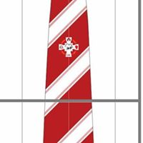
It was a privilege to be the club PRO during such a memorable 2018 season, (a position I have enjoyed to hold since 2011), to have people coming up thanking me for keeping the twitter feed going with match updates or seeing posts on our Facebook page shows the value in club social media & Dromtarriffe GAA has a great profile with nearly 3,200 twitter followers and 1,054 Facebook likes. Our club has enjoyed media exposure thanks to our footballers, & I would like to thank all who took part in interviews on behalf of the club – ye all represented our club professionally. To Ger as Chairman of the club for the past few years, thanks so much for your support and advice, Noel as secretary is second to none – it is very easy to work with Noel. I thank Andrew our treasurer especially for your assistance with our Family day and all who have helped with the club in any way through the year – finally I congratulate Chloe and Conor on your fantastic year with Cork LGFA & GAA respectively & Jack for your U21 Hurling involvement- we hope other will get an opportunity to wear a Cork Jersey and so wish in advance all those lucky enough in 2019 a very successful year. Reminder our club social is on February 9th in the Gleneagle Hotel – Tickets 35 euro available soon – see club social media for information. New club tie – available to order now from the social committee – price 15 euro.

Some of the years highlights
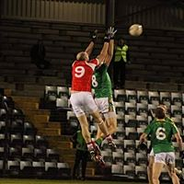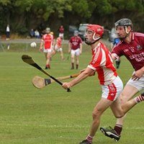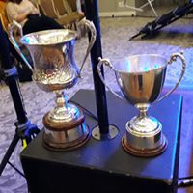
Sharon O Keeffe 11/1/19

